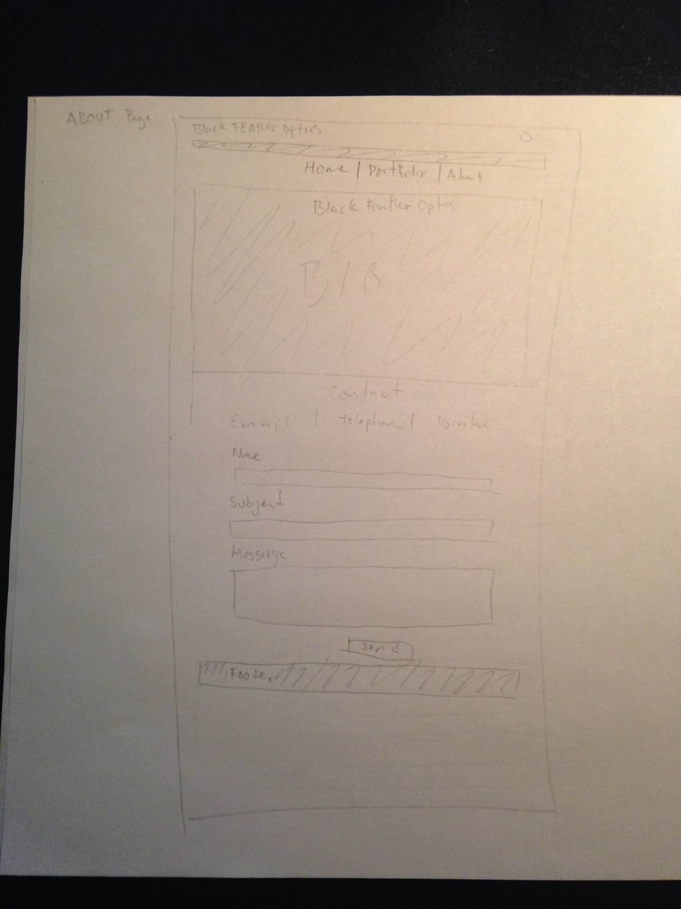
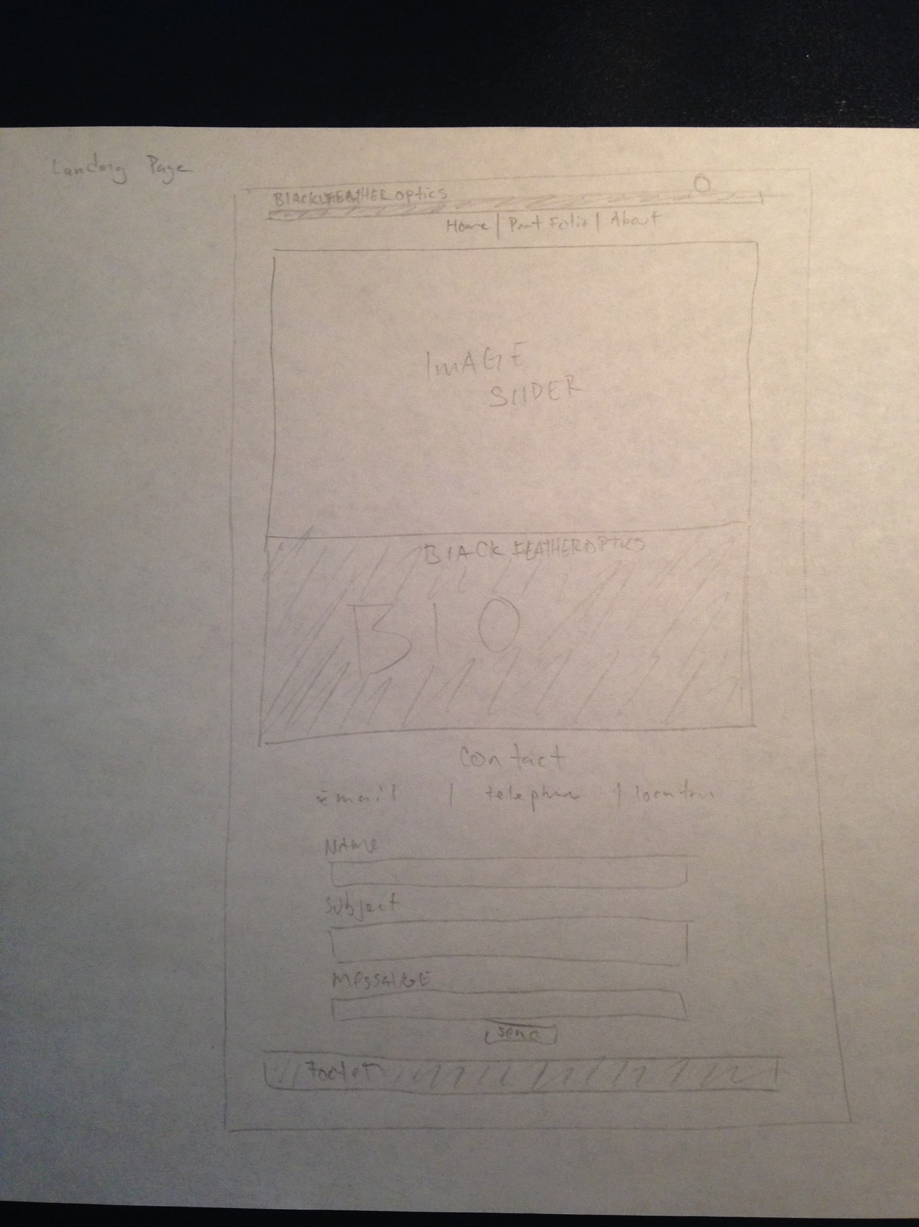
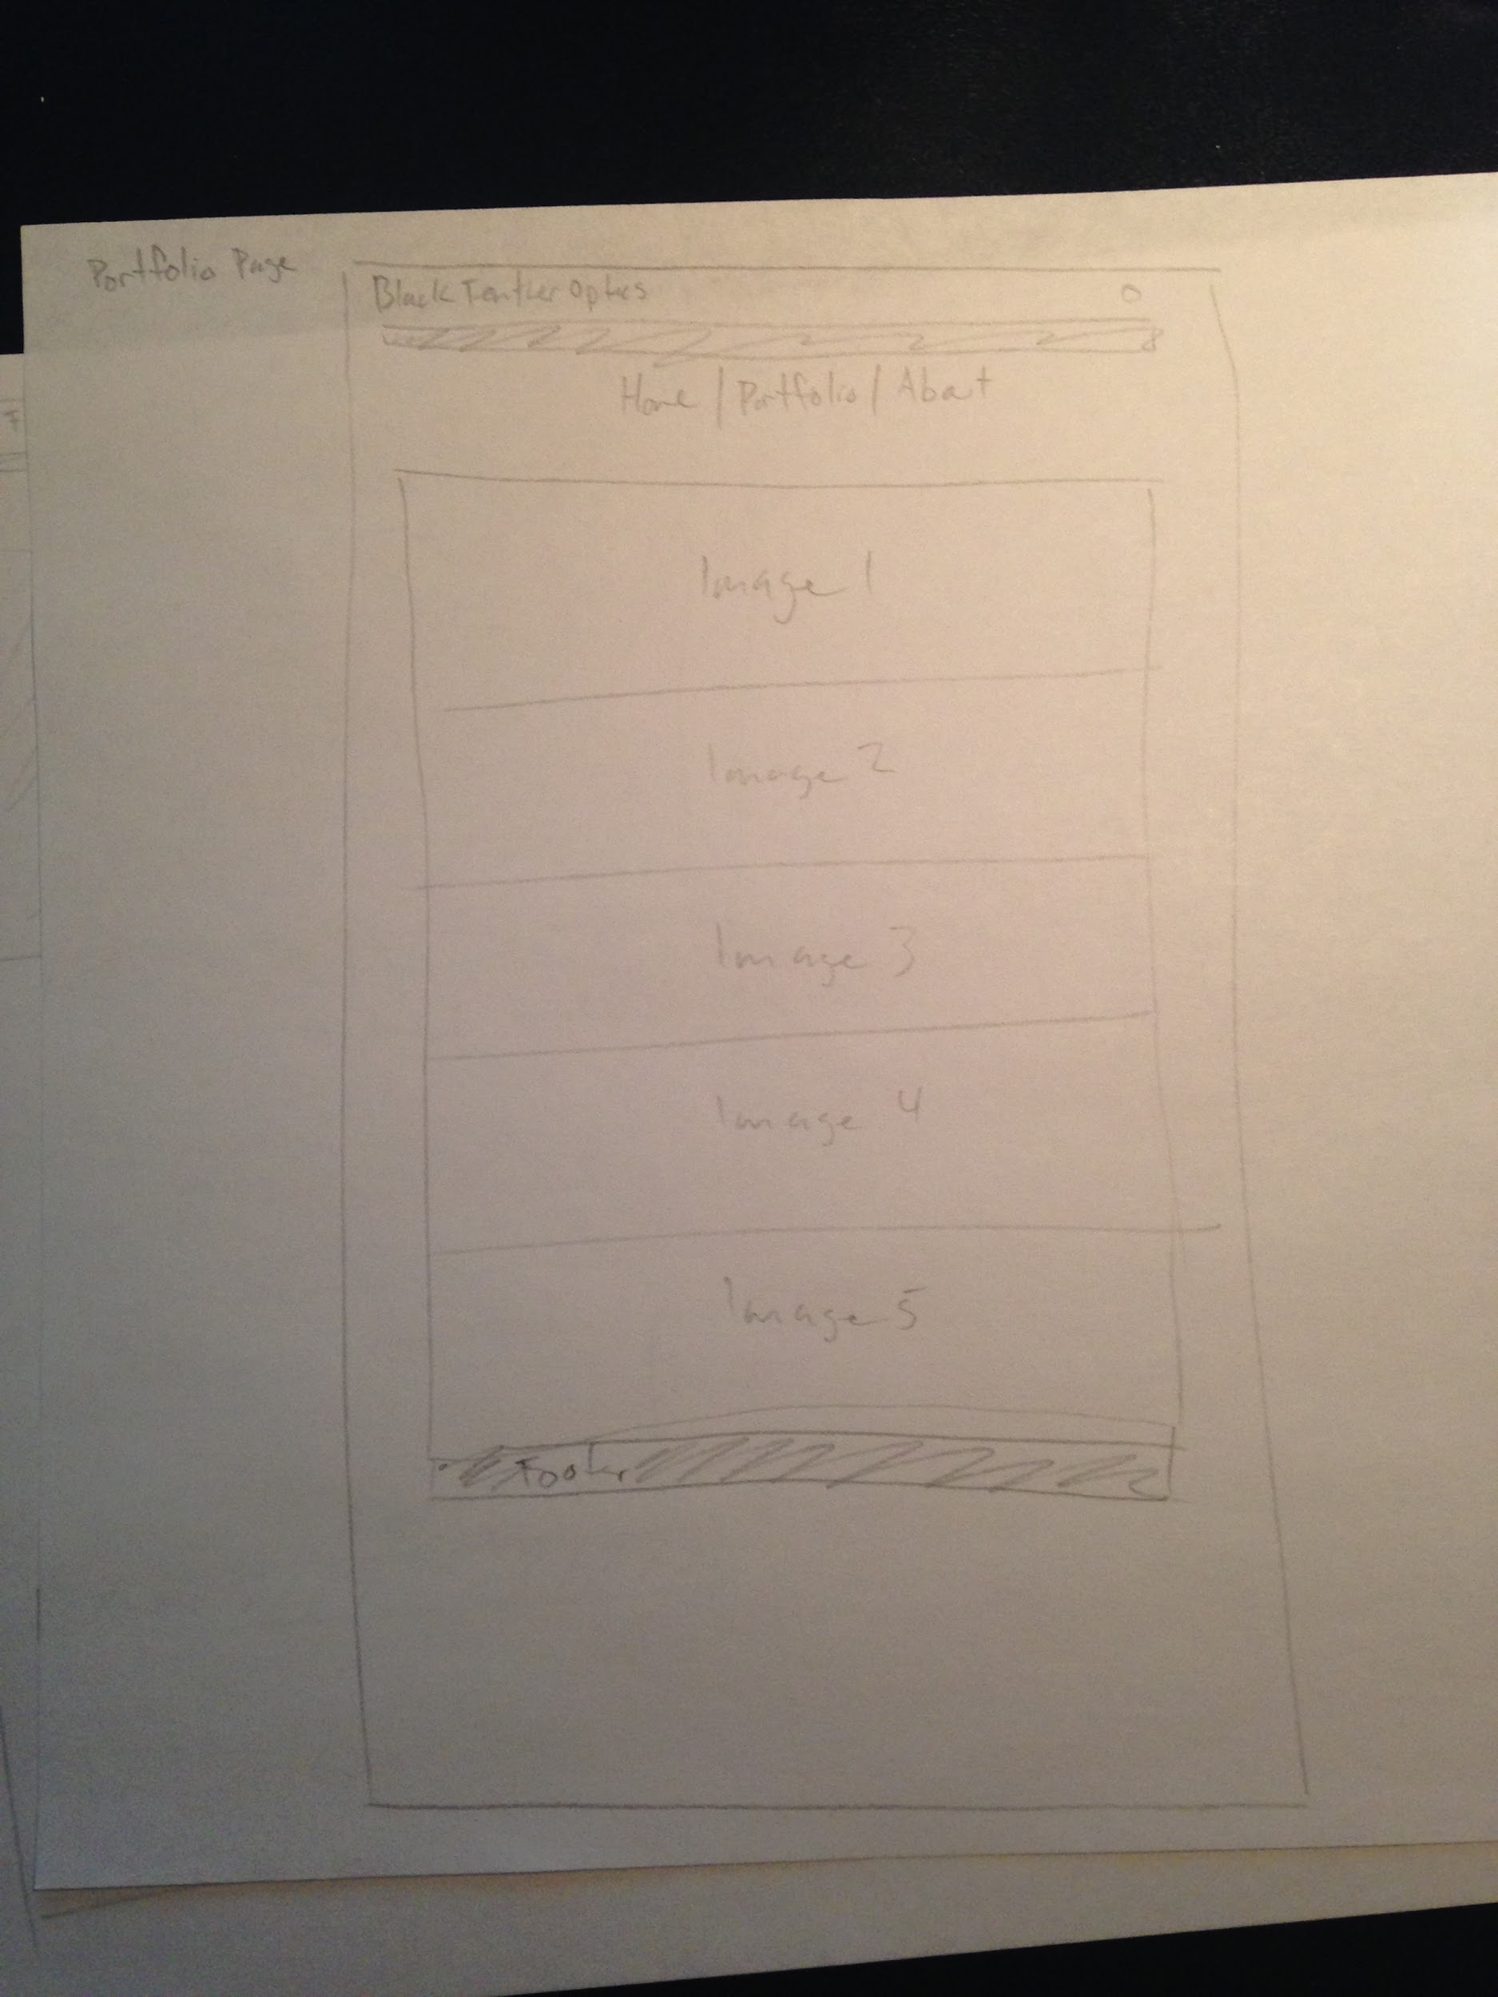
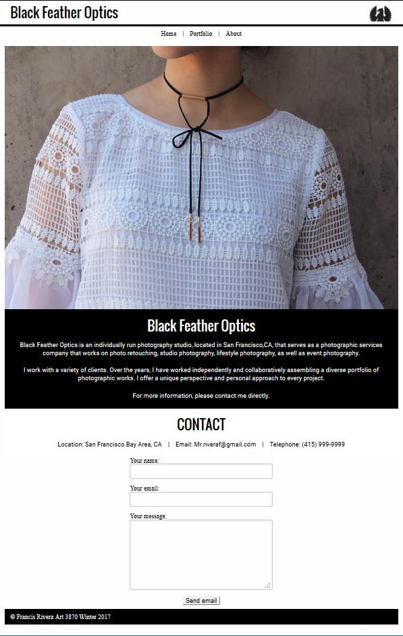
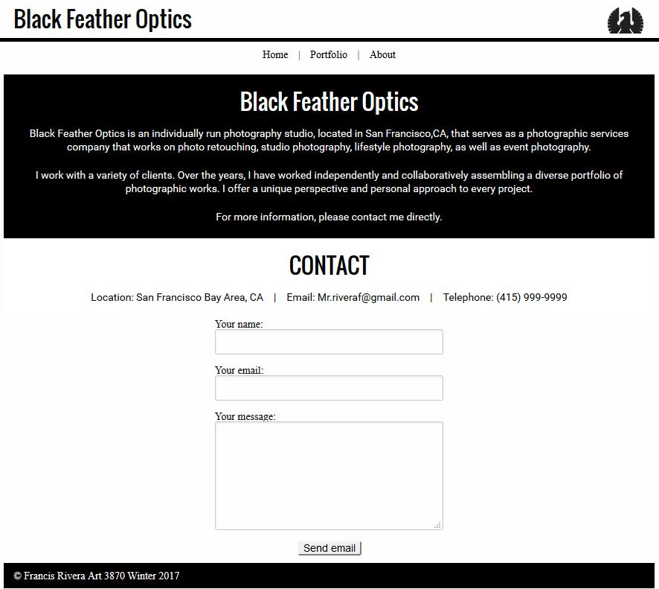
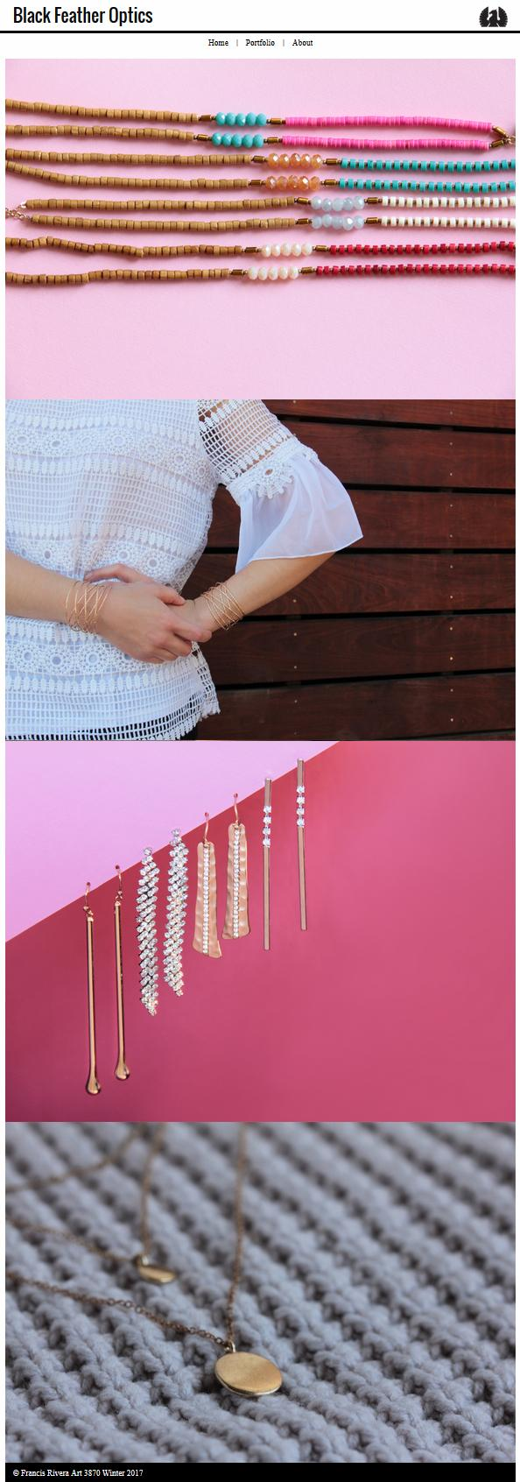
ART 3870 PROJECT SUBMISSION TEMPLATE
complete this template, export to pdf and submit on blackboard

NAME: Francis Rivera
NET ID: MX5987
COURSE: 2017 / WINTER /SECTION 01

Project Title: Personal Homepage

Project Description:

Project URL on github.com: https://github.com/blackwing415/final

Project URL on github.io: https://blackwing415.github.io/final/

Project Sketches:
(one for each page in the project – scaled to take the whole page width, not distorted/stretched)

Project Design considerations:
(Explain 3 of your major design decisions)

- I originally wanted to do a horixzontal side scroll, but I got lost in the code and switched it to vertical so I know where everything goes.
- I wanted to tell a simple story, and made my page about the distance from the earth to the moon, but I added twists.
- I went for an info graphic like layout and design.

Project Screenshots:
(one for each page in the project – scaled to take the whole page width, not distorted/stretched)
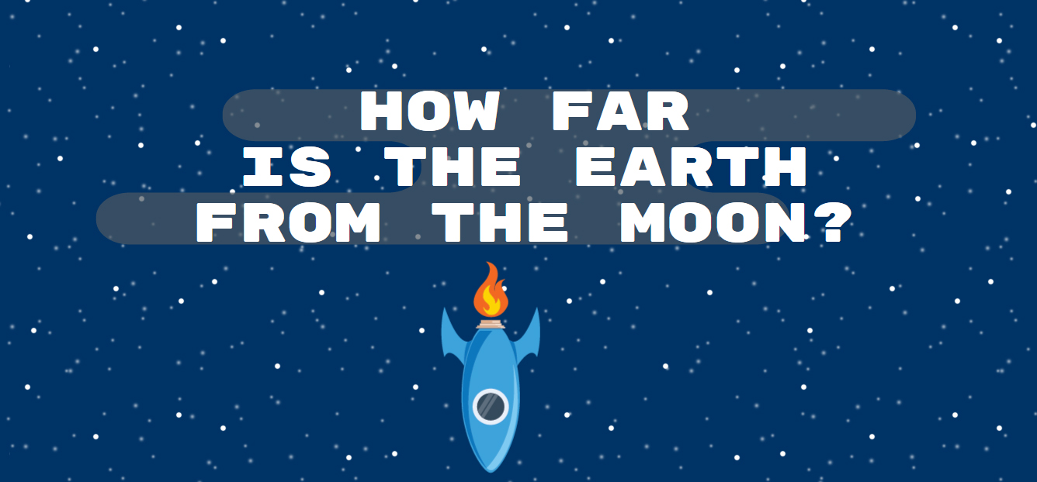

Project Reflection:
(250 words – reflective writing –What was the most challenging part? What was the most exciting part now that the project is done? What did you learn in this assignment, what is your biggest takeaway?)

The most challenging part of the project for me was converting a horizontal side scroll to a vertical scroll. It took me a few days to remap and do my layout all over again. I also had problems with the z-index and the object positions. I still have a problem with the window size, because that throws off everything for my site. I cant seem to place objects outside of my wrapper, so I cant have a set size without having more issues.

The most exciting part was seeing everything work, but unfortunately it only works from my laptop sized browser window. If it isnt the right size it will look off and not be right. That is one of my biggest concerns for this project, and that is what has me worried the most, especially for the presentation.

I learned more about position, parallax, and making everything in the right place, because it was hard to figure out the math involved with the sizing of the wrapper and everything. I want to learn more about parallax and see what more I can do with it so that I can make a more professional and clever site one day that can utilize it to its fullest extent.

My biggest takeaway is how much time and work goes into making a long scroll site. There is a lot of factors that will make everything move in such a way that It may or may not be great.

